**Prototype User Guide and Environment Setup**

**Environment Needed**

**What You Need:**

* Internet Access
* Laptop or Desktop Computer
* Browser (preferably Chrome and/or another)
* Project Files (available on github <https://github.com/4Shaneob/NewUITest>)
* Xampp Server or Wamp Server
* Database imported from file to localhost server
* User Account Details
* Sandbox PayPal Account Details

**Guide**

For Project Files

1. Got to <https://github.com/4Shaneob/NewUITest>

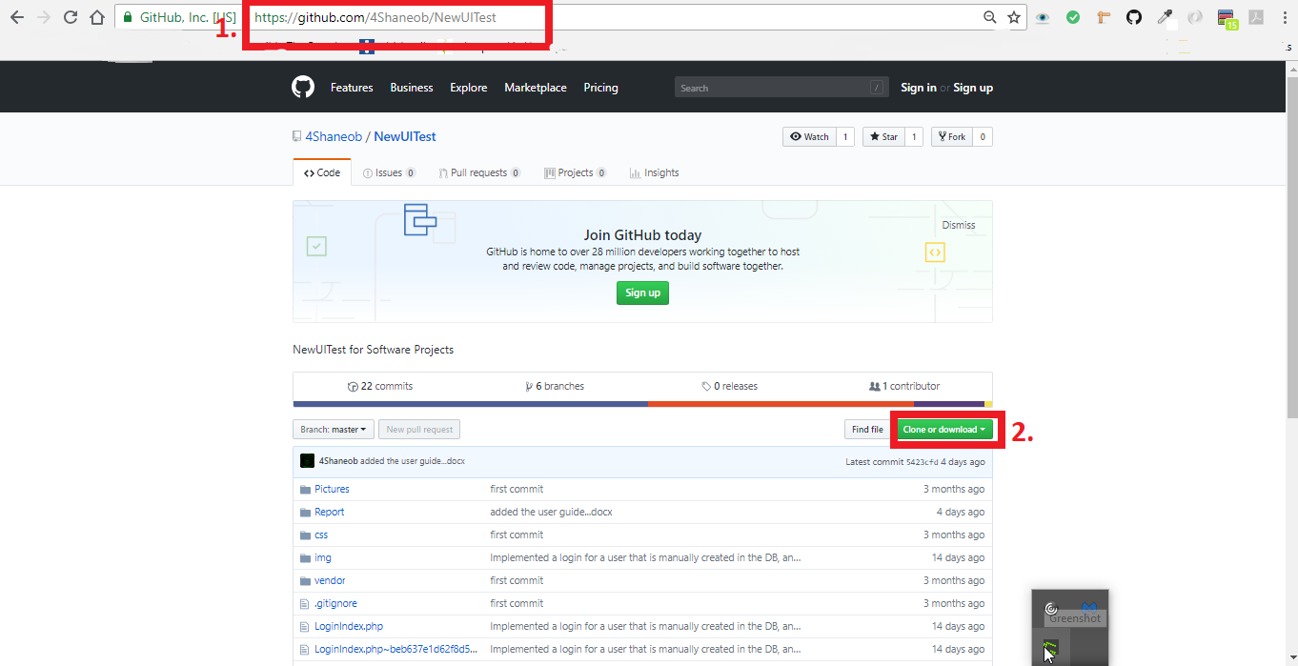

1. Click on the “clone or download” button
2. Click on Download ZIP.

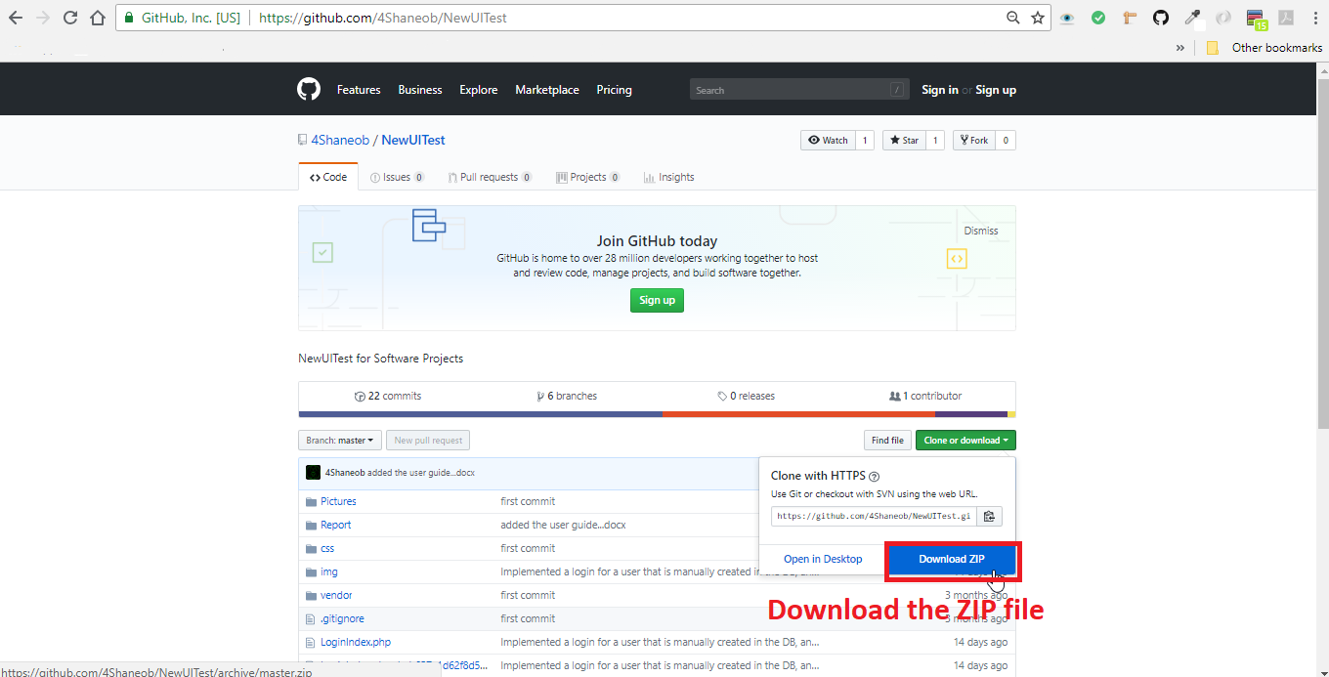

1. Save to Desktop

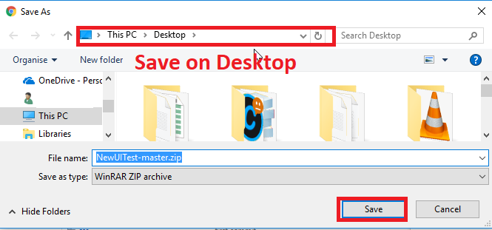



For XAMPP Setup

1. Go to <http://www.apachefriends.org/index.html>
2. Select Download for Windows

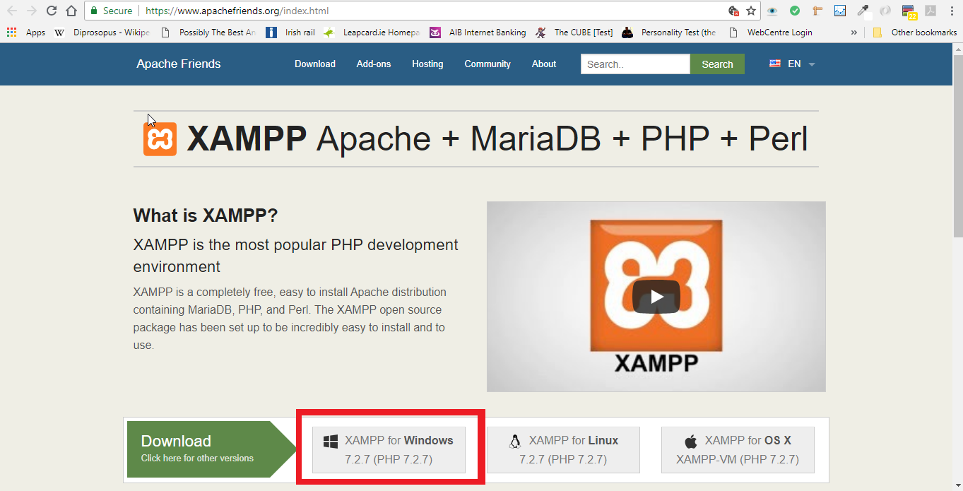

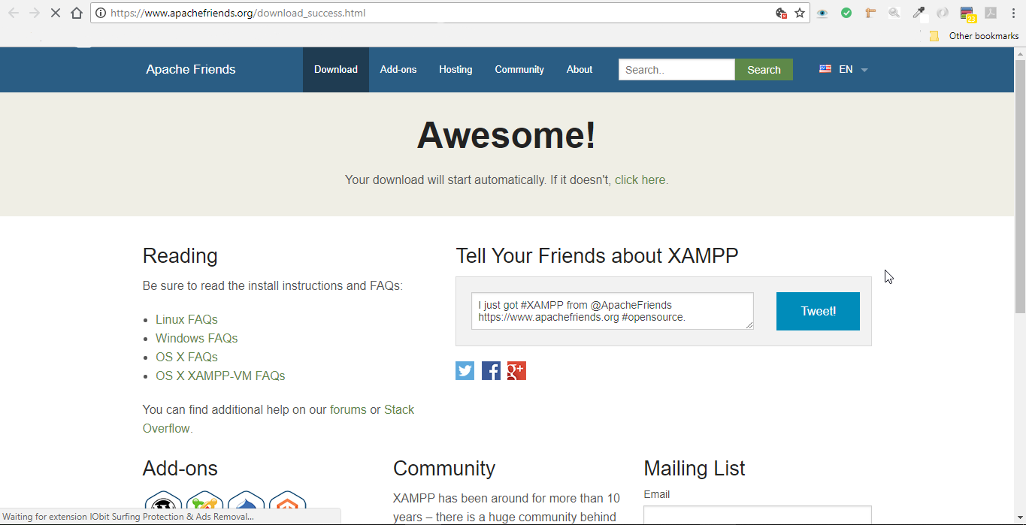

1. Once downloaded, run the executable file.
2. Follow the default Install Wizard Setup

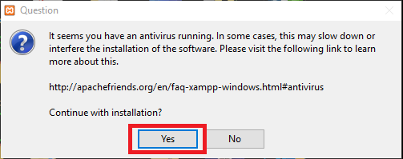

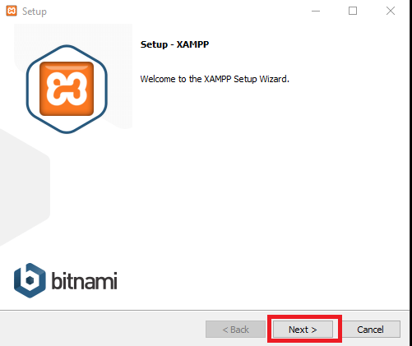

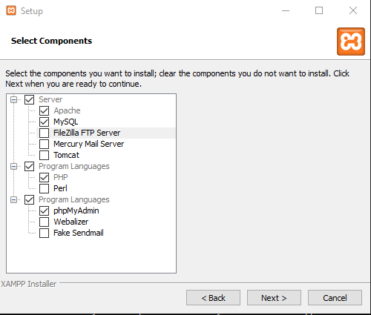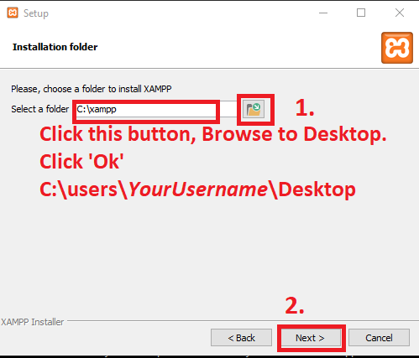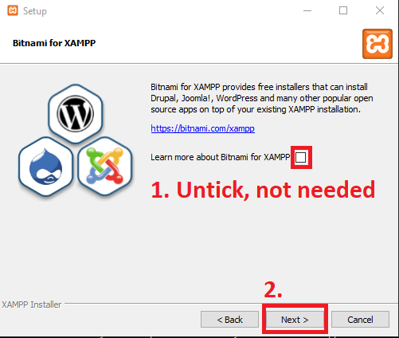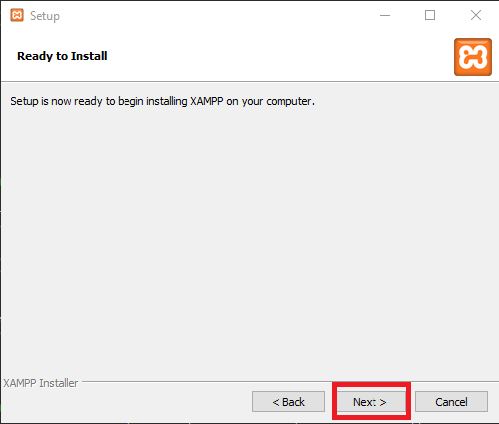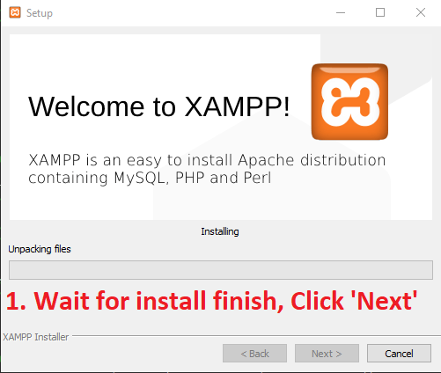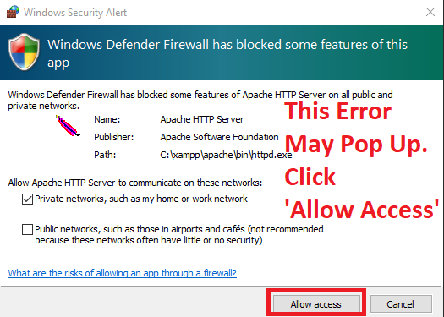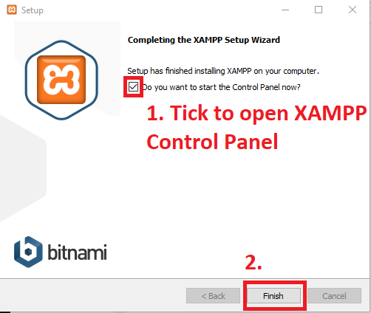

1. Once XAMPP is installed go to location of installation
2. Open “XAMPP-control.exe”

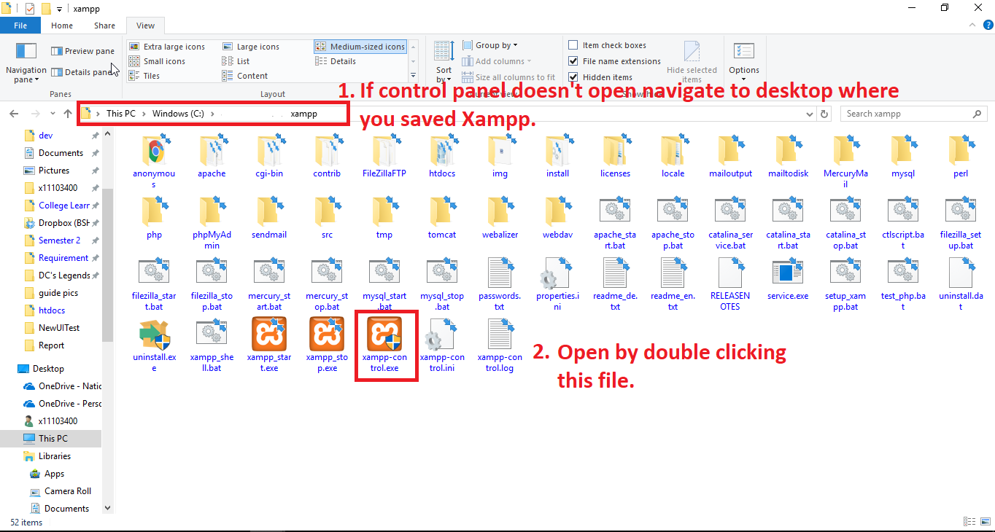

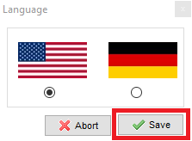

Import Database File

1. Once XAMPP Control is open
2. Click “start” button beside the Apache and MySQL modules. 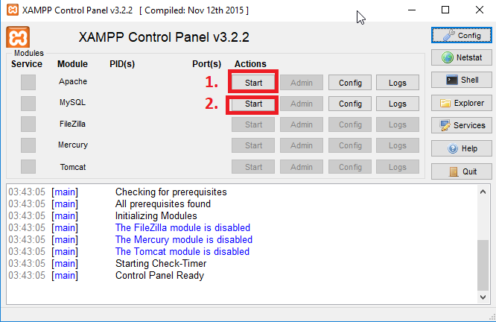

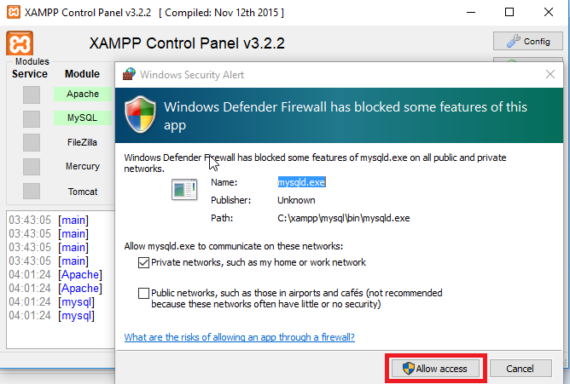

1. The click on ‘Admin’ beside MYSQL Module. This opens PHPmyAdmin in a browser window.
2. Log in to PHPMyAdmin. (Admin root)
3. Click on ‘New’

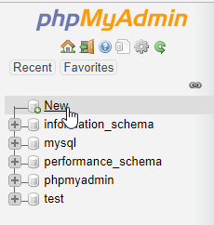

1. Under Create Database type ‘Company’,
2. Then Click ‘Create

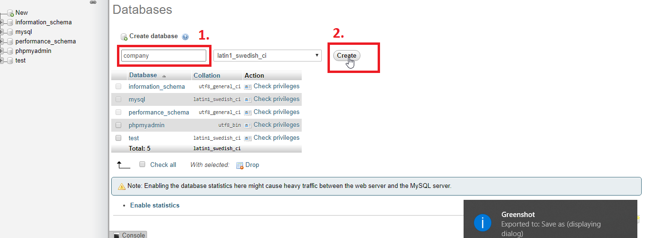

1. Click on the “Databases” Tab

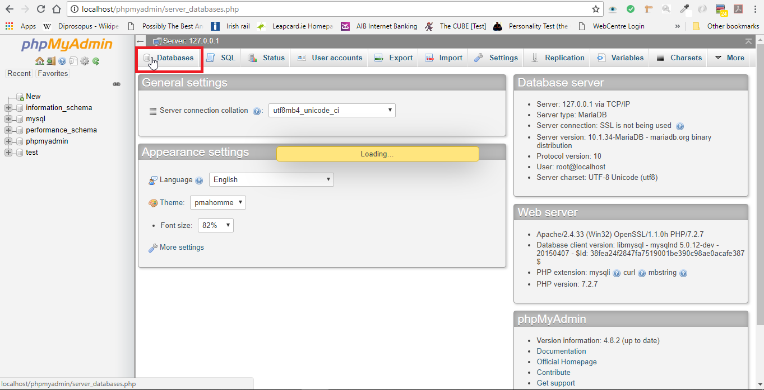

1. Then click on the “Import” Tab

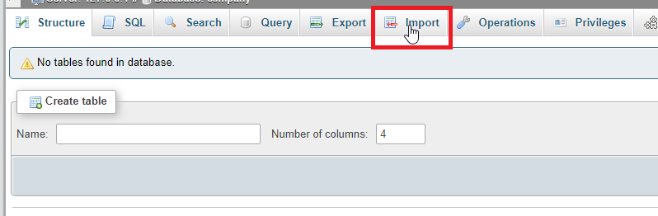

1. Under “***File to import”*** click on the ‘choose File’ Button.

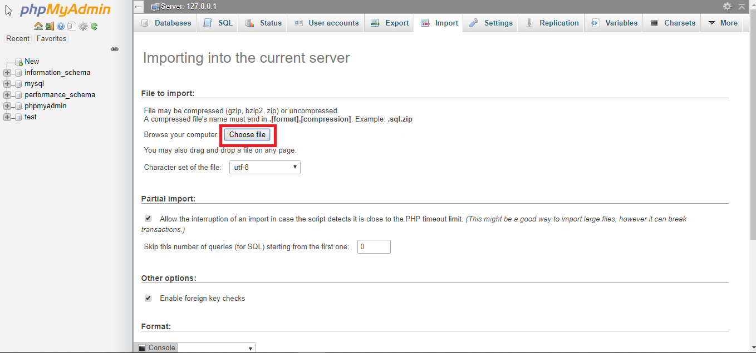

1. Select the “company.sql” file and Open.

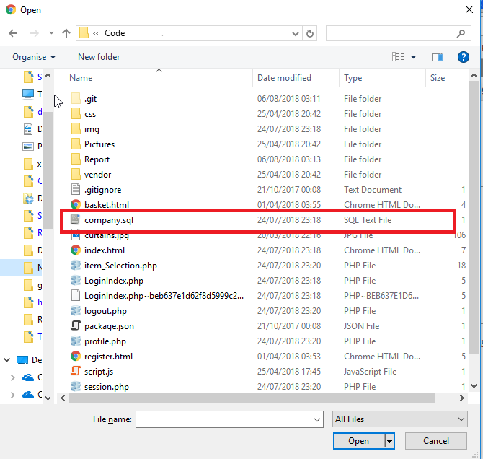

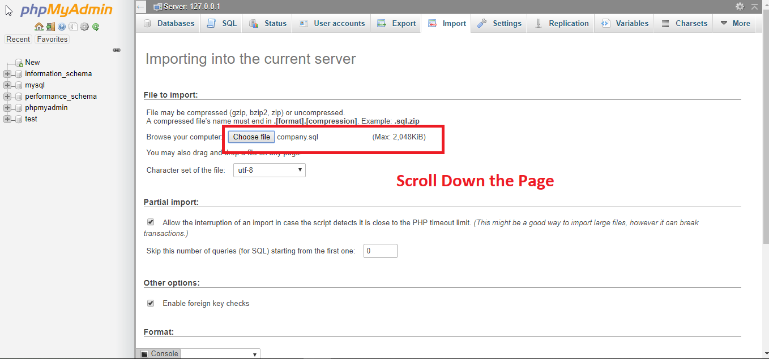

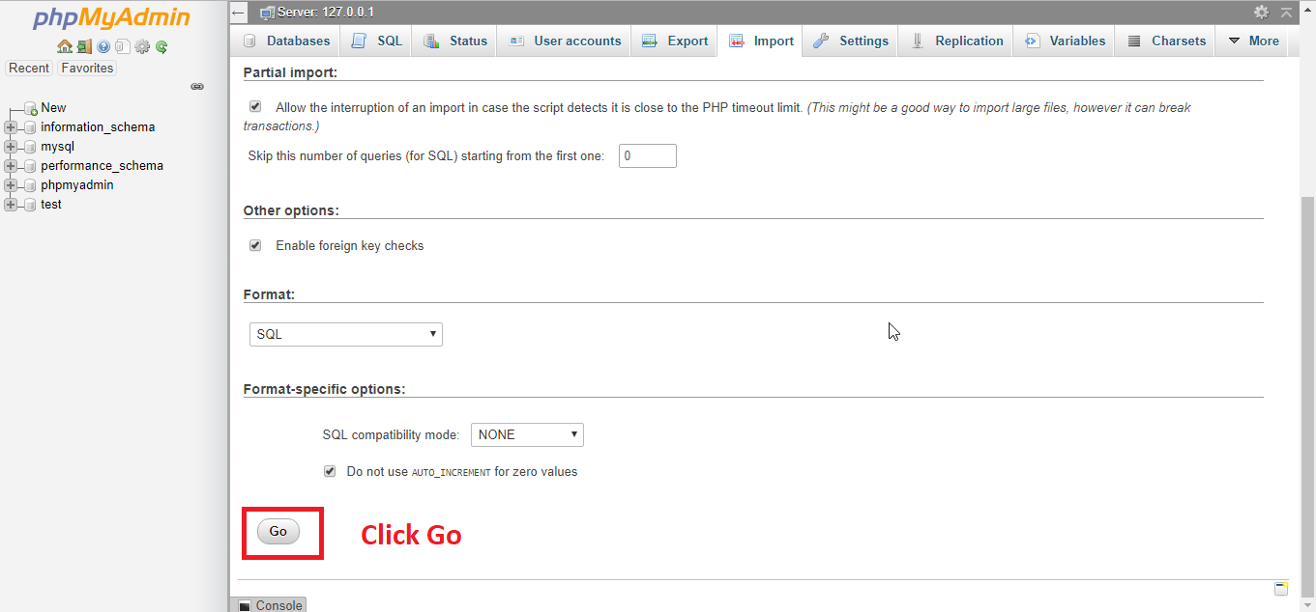

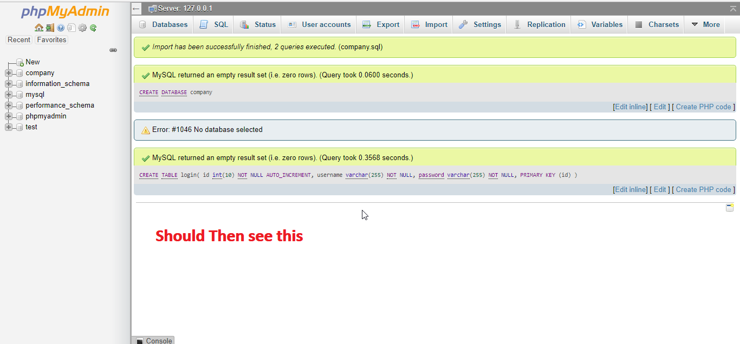

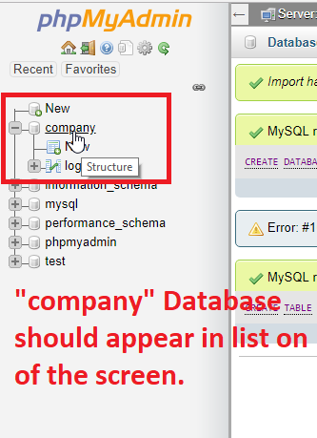

Run the Project

1. In file explorer, browse to the location of the Project files you downloaded right Click the zip file.

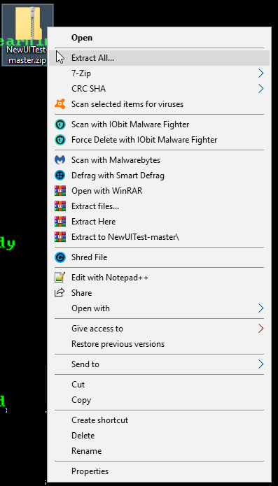

1. Click ‘Extract All’

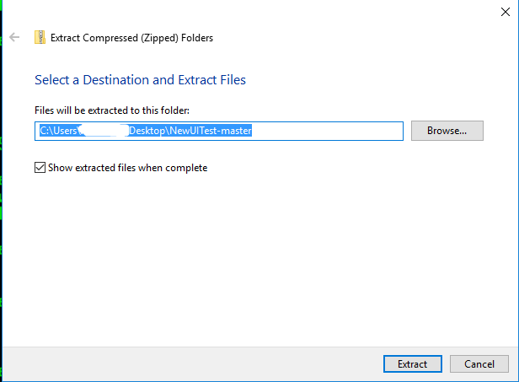

1. Go to \XAMPP\htdocs

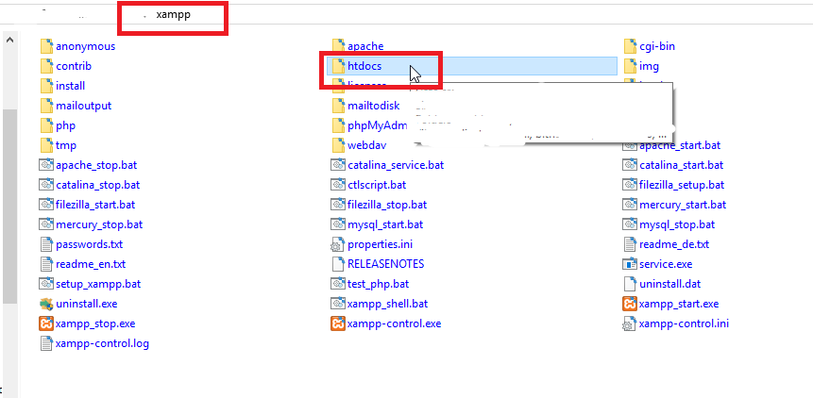

1. Select the default files and right click and delete

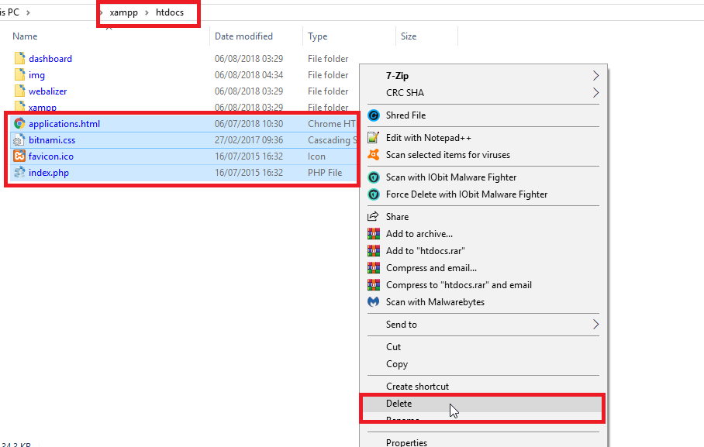

1. Copy the Project files to \XAMPP\htdocs

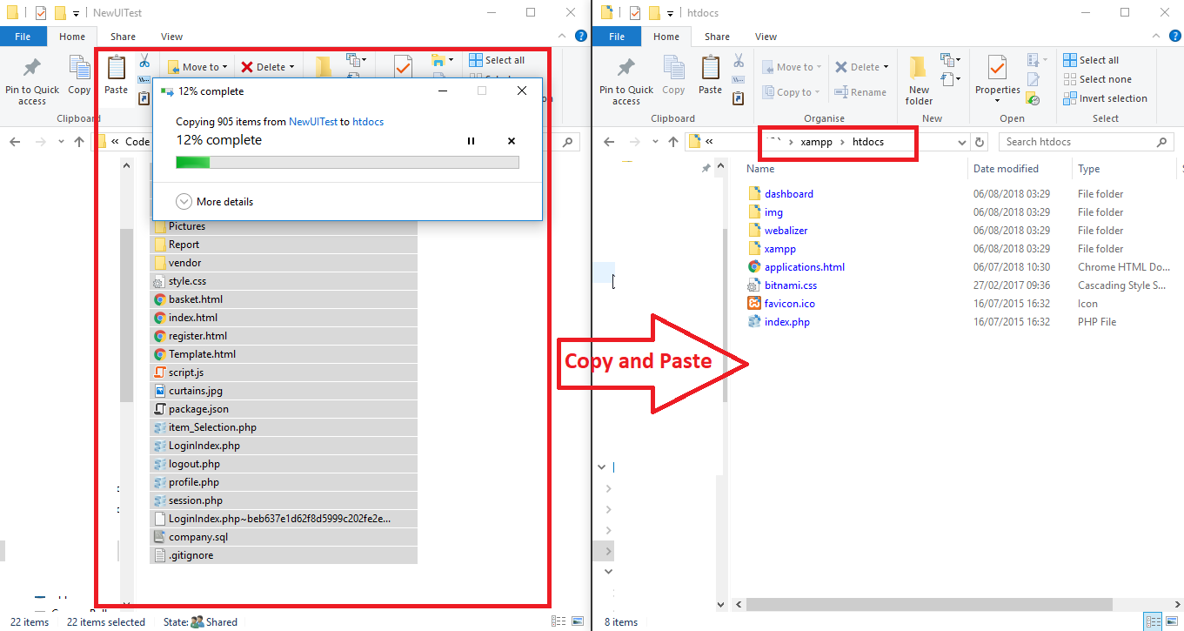

1. Once files have copied open a browser
2. In the URL address bar type: “localhost” or “127.0.0.1”

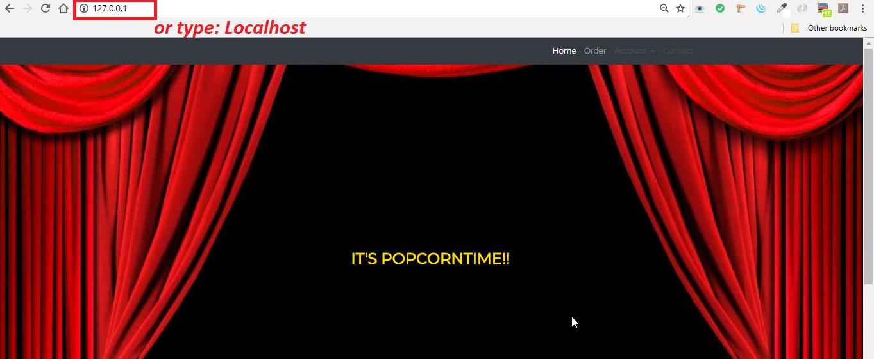

Login Details

1. For Website:

|  |  |
| --- | --- |
| **Email:** | test@prototype.com |
| **Password:** | P@ssword |

1. For euro(process in French):

|  |  |
| --- | --- |
| **PayPal Username:** | test2@popcorn.com |
| **PayPal Password:** | P0pcorn18 |

For GBP(process in English):

|  |  |
| --- | --- |
| **PayPal Username:** | test@popcorn.com |
| **PayPal Password:** | P0pcorn18 |

The prototype

1. It will open on the index.html page, displaying a Login, Guest and disabled register button. There is also a navigation menu on the top of the page.
   1. The login button redirects to a login page where you will log in using predetermined login credentials.
      1. Type in the username and the password.
      2. If you type either incorrectly then you will receive an error.
      3. If the username is not an email you will receive an error.
      4. Once you log in the page will redirect to the items page which will say welcome “user”.
   2. The guest button should direct to the items page which should only say welcome under the navigation page.
2. You can then choose 1 item fill in the required selection and click the add to cart.
   1. This will redirect in a new browser tab to the PayPal Cart.
   2. To add another close tab and go back to the item selection page.
   3. Choose a different item and repeat until till you have selected as many items as you wish to continue.
3. Once done go back once more select the view cart button on the items page.
4. Click buy now.
5. It will ask for PayPal log in credentials enter the sandbox details I have provided.
6. Continue through the mock payment until complete.
7. On all pages you view resize the browser window to mimic a mobile device.